C.V
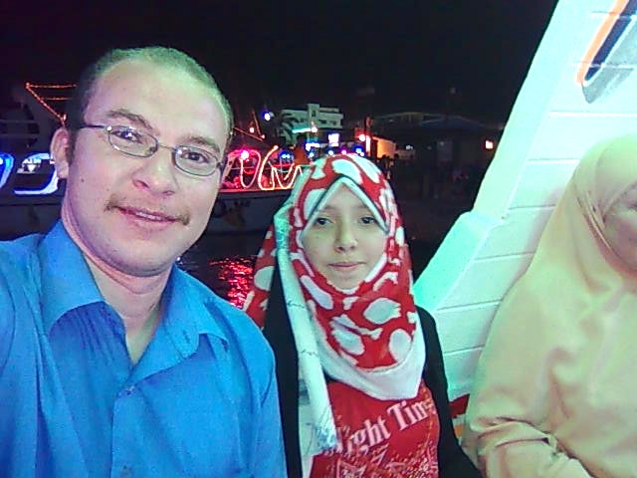
• Mohamed Abd el paset Mohamed darwish
• Born in Assiut
• 18 / 3 / 1981
• holds a bachelor's degree in Education Division of Art Education quality assessment in very good with the honors and the first installment in July 2001.
• Appointed as a lecturer at the Faculty of Specific Education, Division of Art Education, Assiut University
30 / 12 / 2001.
• holds a Diploma in education quality for two years, the role of the May 2004 Department of Art Education grade of wood works very good.
• The registration of a master's degree in 2004 entitled:
"Values and the Fine Art of the wood-carving in the Fatimid era, and benefit from the development in the woodwork"
• Under the supervision of both: - a. D / Munir Mustafa Darwish, professor of wood works part-time Faculty of Art Education, Helwan University, and Dr. / Mohamed Mohamed Ali Abu Ahmed, a teacher Wood Faculty of Specific Education, Ain Shams University,
• received a master's degree in Education Specific works of art education, wood Distinction in 2006
• Appointed as an assistant lecturer at the Faculty of Specific Education, Art Education Department, Assiut University in 2006.
• register for the doctoral degree 12 / 3 / 2009 entitled:
" Innovation wooden forms through the shaping of Islamic architecture items utilizing of computer programs "
Under the supervision of both: - A. D / Abdel Moneim Mahmoud Haggan Wood, professor emeritus and head of works of art and folklore, former Faculty of Art Education - Helwan University, a. M. D / Ashraf Mahmoud Mohamed Aasar Assistant Professor of Wood and Dean of the College of Qualitative Education for Education and Student Affairs, Ain Shams University
• Exhibitions: --
• Graduation Exhibition, Faculty of Qualitative Education, Assiut University, the annual collective from 1998 to 2001.
• Youth Salon, Palace of Culture of Assiut in 2001 until 2004.
• Spring exhibitions Assuit Culture Palace from 2001 until 2003.
• Art Gallery Alosgal first Horus gallery, Faculty of Art Education, Helwan University, 2004.
• Personal Interests: --
• table tennis player from 1988 to 2004.
• Assiut team table tennis in 1995.
• table tennis coach for the University Club in Assiut summer of 2005.
• Phone elected during the college years of schooling.
• centers and awards: --
• Certificate of appreciation from the Culture Palace of Assiut.
• Certificate of Merit from the Faculty of Art Education for participation in the exhibition of artistic works first.
• A set of certificates of merit during the years of college study, notably the Certificate of Merit from the 6 October University for outstanding students at Egyptian universities.
• A set of certificates of appreciation in many centers for table tennis, namely: --
- Second place in table tennis to keep in 1995
- The second in the Friendship Tournament table tennis at the level of the Republic of the institutes of higher in 1998
- Seventh place on the University table tennis in 2000
- Third place at the university in table tennis in 2003
- First place in the university in table tennis in 2004

